# **Common Structure of SenSys Security Papers**

* In the Introduction, they illustrated the method as follows,
* 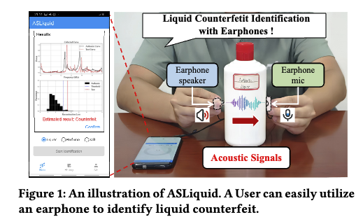
* 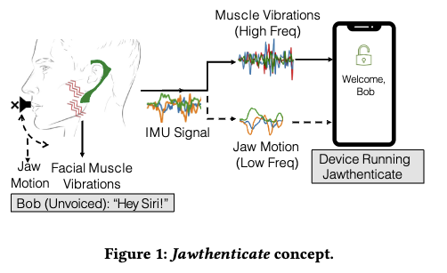
* Talked so much about background and motivation.
* Made one section to discuss potential applications.
* In the Threat Model section, they discussed their methods, real-world use cases, and features in a story form.
* Introduced the system overview in one section and the whole design in another section.
* The system design part took 2.5 pages (they covered the whole system in this section)
* For performance evaluation, they discussed their setup first.
* Discussed performance with a lot of graphs like below:

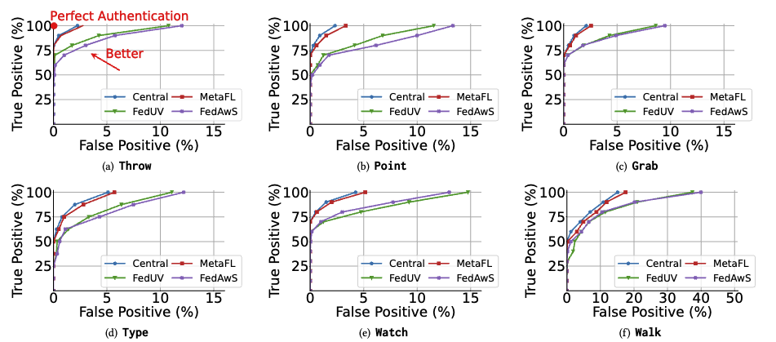

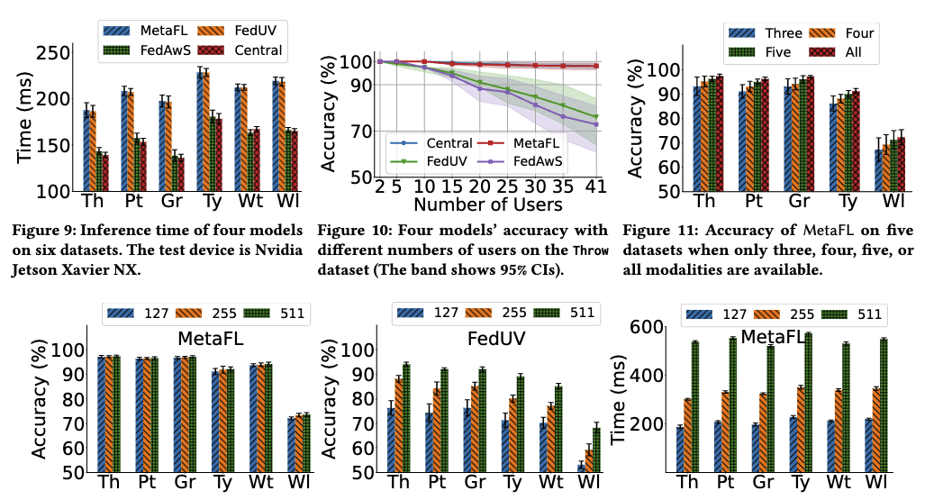

* Did experiments to show the robustness of their approach.
* They also mentioned related work at the end, after the discussion.
* A lot of citations.